Stage 7 – "But you ain't bona fide!"
COURSE DESIGNER: John Royer (Outdoor Dynamics)
SCORING: Comstock 24 rounds.
TARGETS: 11 cardboard targets, 2 steel targets
SCORED HITS: 2 Best hits per carboard will be scored.

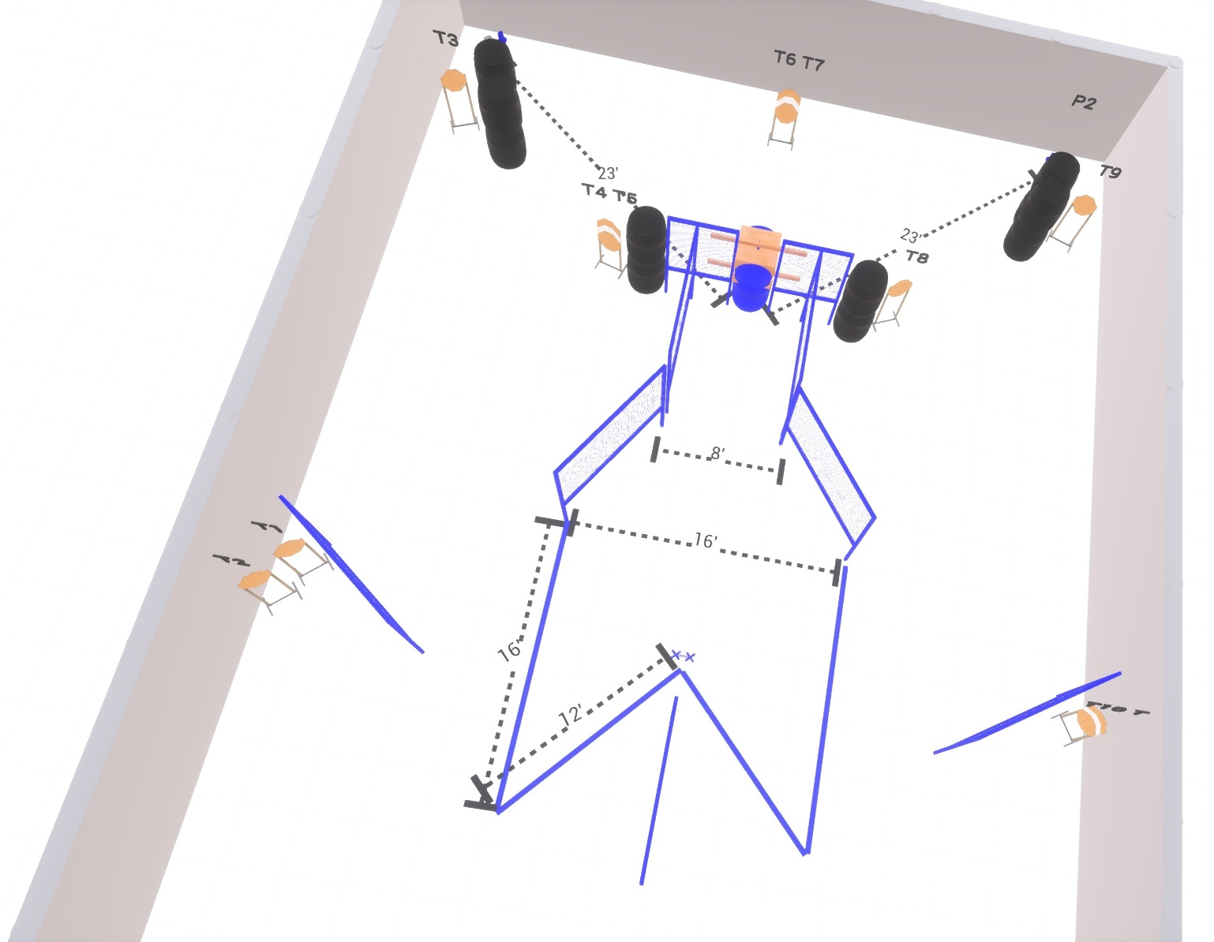

Written Stage Briefing:

Stage 7 – "But you ain't bona fide!" - is a 24 round, 120 point, Comstock Course. There are 11 cardboard targets and 2 steel targets.

Starting with Both feet on the Shooting Sports Innovations Xs.
Handgun is loaded and holstered, wrists below belt.
PCC is loaded held in both hands, stock on belt.

On the audible start signal, engage targets from within the shooting area.

USPSA / NROI Range Commands:
- Make Ready
- Are you ready?
- Standby
- If finished, unload and show clear
- If clear, hammer down and holster (Handgun)
If clear, hammer down and flag (PCC)
If clear, cylinder closed and holster (Revolver)
- Range is clear

Setup Notes:
12 Single Wall Stands
2 Double Wall Stands
2 Full Walls
2 Half Walls
1 Outdoor Dynamics Turret Wall
8 Target stands / 16 target sticks
2 Mini Poppers + bases
12+ Barrels



